Go to Settings

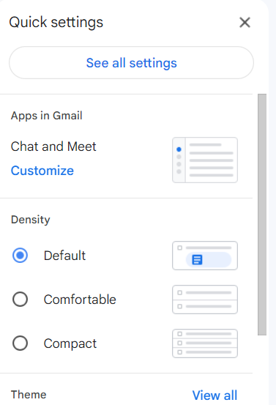Then go to “See all settings”

In General tab scroll down and find “Signature” section

